**Introduction to Electronic Mail**

* Electronic Mail (e-mail) is one of most widely used services of Internet.
* This service enables Internet users to send formatted messages (emails) to others worldwide.
* The person who is sending mail is called sender and person who receives mail is called recipient.
* It is just like postal mail service.

**ARCHITECTURE**:

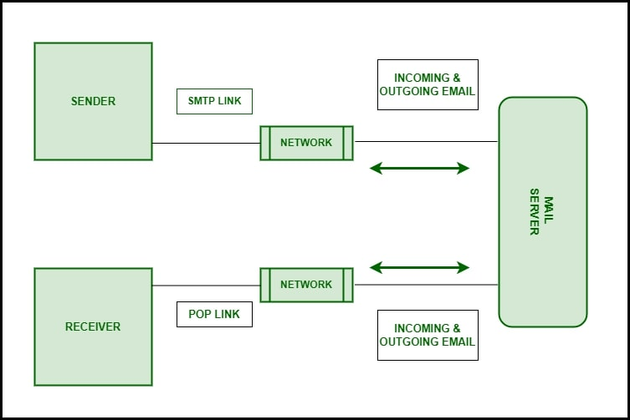

### Components of an Email:

* **Sender**: Creates and sends an email with the intended information.
* **Receiver**: Receives the email sent by the sender.
* **Email Address**: Serves as a unique digital address for email communication.
* **Mailer**: Software for reading, writing, managing, and deleting emails (e.g., Gmail, Outlook).
* **Mail Server**: Handles the sending, receiving, and management of email data.
* **SMTP**: A protocol for transferring emails over the Internet.

### Protocols of Email:

Emails basically use two types of standard protocols for communication over the Internet. They are:-

**POP:**

* POP (Post Office Protocol) facilitates email communication by transferring messages through a service provider, similar to a post office.
* It allows internet disconnection after sending, does not require leaving a copy on the web server, and consolidates emails from multiple addresses.
* POP is unidirectional, transferring information only from sender to receiver.

**IMAP:**

* Stands for Internet Message Access Protocol and enables bidirectional email communication.
* Removes the need for server storage of conversations.
* Offers advanced options, such as confirming if emails are read by the receiver.

### Working of Email:

• Emails are sent using mail programs and then passed to the Simple Mail Transfer Protocol (SMTP).

• The email is stored on a server and later accessed using POP or IMAP protocols.

• If the receiver's email is on another domain, SMTP connects with the receiver's DNS.

• If there are network issues, the email is placed in the receiver's SMTP queue.

• If the email stays in the queue too long, it is returned to the sender as undelivered.

### From Sender to Receiver:

• The sender writes the message, sends it through SMTP to the Mail Transfer Agent (MTA), which communicates with the receiver's MTA via DNS to find the receiver's mail service.

• SMTP transfers the email between servers, with the receiver's MTA delivering it to the local computer.

• POP deletes the email from the server, while IMAP keeps a copy on the server, allowing the user to modify it.

**Services provided by E-mail system :**

* **Composition**: Creating messages using a text editor.
* **Transfer**: Sending the mail from sender to recipient.
* **Reporting**: Confirming mail delivery status (delivered, lost, or rejected).
* **Displaying**: Presenting the mail in a user-readable format.
* **Disposition**: Deciding what to do with the received mail (save or delete).

### Advantages of email:

• Convenient, fast global communication.  
• Easy message storage and search.  
• Ability to send/receive attachments.  
• Cost-effective compared to traditional mail/fax.

### Disadvantages of email:

• Risk of spam and phishing attacks.  
• Information overload.  
• Decreased face-to-face communication.  
• Miscommunication due to lack of tone and body language.

From Sender to Receiver: